CARC Membership Form

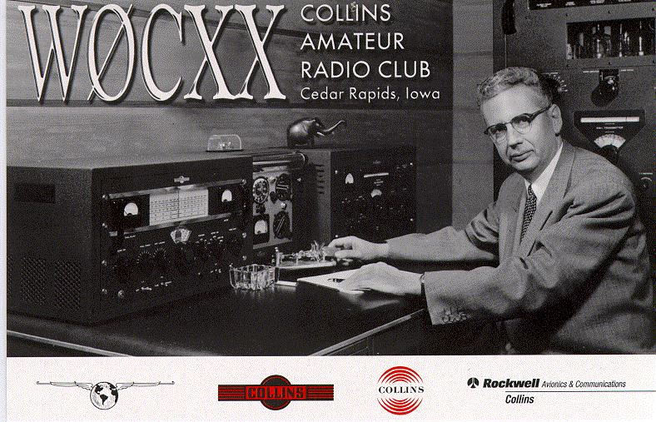
The club e-mail address is W0CXX@rockwellcollins.com
_ Collins Amateur Radio Club OFFICERS: _
President Charley Snodgrass KCØCD Retiree kc0cd@arrl.net
Vice President Mike Hynek ACØPB 137-141 295-0627 michael.hynek@rockwellcollins.com
Treasurer Christopher Caldwell WCØYGW 145-100 263-5466 christopher.caldwell@rockwellcollins.com
Programs Gregg Lind KCØSKM 137-146 295-0008 kc0skm@arrl.net
Editor Vince Loschiavo N2AIE 152-250 263-1457 n2aie@arrl.net
Secretary Bill Caldwell NØLNO 166-111 295-8624 william.caldwell@rockwellcollins.com
Membership/PR Tim Busch NØCKR Retiree timcfi@yahoo.com

Station Managers:

Building 112 Dave Cripe NMØS 108-102 295-1118 nm0s@arrl.net
Main Plant Mike Hynek ACØPB 137-141 295-0627 michael.hynek@rockwellcollins.com

FY19 Activity Registration Form

Collins Amateur Radio Club

Applicant Information:
Name: _____________________________________________
(Last, First, Mi)
Call sign: _____________________
(Not required for membership)
Home phone number: (_____) ______________________
Mailing address: Street: _____________________ City: ________________
State: _____________________ Zip: ________________
Email address: ________________________________
Email address (for Newsletter): ________________________________

Collins Information (If Applicable):
Collins Mail station: _______________________________________
Collins Email address: ________________________________
Collins phone extension number: (_____) ______________________
Retired from Collins? _____ (Y/N) and request onsite Retiree Access*. _____(Y/N)
Amateur Radio Information:
Are you a Collins Collectors Association (CCA) member? ____ (Y/N)
Are you an ARRL member? ______ (Y/N)
What is your License class? ______ ( A,E,G,N,T,T+,X)
Do you have any special area of interest in Amateur Radio? _________________ _________________________________________________________________
Mark the modes/bands that you are active on:
Bands CW DATA IMAGE MCW PHONE PULSE RTTY SS TEST SATELLITE
HF
(160m to 10m)
VHF
(6m to 1.25m)
UHF
(70m to 33m)
Micro Wave
(23m and Above)

Would you be interested in helping the club with any of the following:

Meeting Presentation
Special Op Events
K-12
Community Service Events

Antenna Parties
Shack Setup
Rig Troubleshooting & Repair
Help Comment:
Elmering
B-29 Radio Project
Other – see comment

The fee to participate as a member in the Collins Amateur Radio Club is $20.00, make checks payable to:

Collins Amateur Radio Club

Mail to: Collins Aerospace, c/o Christopher Caldwell, M/S 145-100

400 Collins Road NE

Cedar Rapids, Iowa 52498

* For retiree access, please submit a facility access request if not already in the files.

RELEASE Form

I understand the above named activity is sponsored for recreational purposes only. I also understand the nature of the activity including its possible risks and voluntarily register for participation.
I hereby release Collins Aerospace, Inc. from any claims, demands or damages because of injury or death, other than customary and reasonable medical expenses under the existing company medical plan, resulting in any way from participation in this activity.

Signature: __________________________ Date: ________________

FOR OFFICE USE ONLY
Total amount received: ___________ Cash / Check Check No. ___________
Date: _________________________ Signed: _________________________

